<!DOCTYPE html>

<html>

<head>

<style>

.error {color: #FF0001;}

</style>

</head>

<body>

<?php

// define variables to empty values

$nameErr = $emailErr = $mobilenoErr = $genderErr = $websiteErr = $agreeErr = "";

$name = $email = $mobileno = $gender = $website = $agree = "";

//Input fields validation

if ($_SERVER["REQUEST_METHOD"] == "POST") {

//String Validation

if (emptyempty($_POST["name"])) {

$nameErr = "Name is required";

} else {

$name = input_data($_POST["name"]);

// check if name only contains letters and whitespace

if (!preg_match("/^[a-zA-Z ]*$/",$name)) {

$nameErr = "Only alphabets and white space are allowed";

}

}

//Email Validation

if (emptyempty($_POST["email"])) {

$emailErr = "Email is required";

} else {

$email = input_data($_POST["email"]);

// check that the e-mail address is well-formed

if (!filter_var($email, FILTER_VALIDATE_EMAIL)) {

$emailErr = "Invalid email format";

}

}

//Number Validation

if (emptyempty($_POST["mobileno"])) {

$mobilenoErr = "Mobile no is required";

} else {

$mobileno = input_data($_POST["mobileno"]);

// check if mobile no is well-formed

if (!preg_match ("/^[0-9]*$/", $mobileno) ) {

$mobilenoErr = "Only numeric value is allowed.";

}

//check mobile no length should not be less and greator than 10

if (strlen ($mobileno) != 10) {

$mobilenoErr = "Mobile no must contain 10 digits.";

}

}

//URL Validation

if (emptyempty($_POST["website"])) {

$website = "";

} else {

$website = input_data($_POST["website"]);

// check if URL address syntax is valid

if (!preg_match("/\b(?:(?:https?|ftp):\/\/|www\.)[-a-z0-9+&@#\/%?=~_|!:,.;]*[-a-z0-9+&@#\/%=~_|]/i",$website)) {

$websiteErr = "Invalid URL";

}

}

//Empty Field Validation

if (emptyempty ($_POST["gender"])) {

$genderErr = "Gender is required";

} else {

$gender = input_data($_POST["gender"]);

}

//Checkbox Validation

if (!isset($_POST['agree'])){

$agreeErr = "Accept terms of services before submit.";

} else {

$agree = input_data($_POST["agree"]);

}

}

function input_data($data) {

$data = trim($data);

$data = stripslashes($data);

$data = htmlspecialchars($data);

return $data;

}

?>

<h2>Registration Form</h2>

<span class = "error">* required field </span>

<br><br>

<form method="post" action="<?php echo htmlspecialchars($_SERVER["PHP_SELF"]); ?>" >

Name:

<input type="text" name="name">

<span class="error">* <?php echo $nameErr; ?> </span>

<br><br>

E-mail:

<input type="text" name="email">

<span class="error">* <?php echo $emailErr; ?> </span>

<br><br>

Mobile No:

<input type="text" name="mobileno">

<span class="error">* <?php echo $mobilenoErr; ?> </span>

<br><br>

Website:

<input type="text" name="website">

<span class="error"><?php echo $websiteErr; ?> </span>

<br><br>

Gender:

<input type="radio" name="gender" value="male"> Male

<input type="radio" name="gender" value="female"> Female

<input type="radio" name="gender" value="other"> Other

<span class="error">* <?php echo $genderErr; ?> </span>

<br><br>

Agree to Terms of Service:

<input type="checkbox" name="agree">

<span class="error">* <?php echo $agreeErr; ?> </span>

<br><br>

<input type="submit" name="submit" value="Submit">

<br><br>

</form>

<?php

if(isset($_POST['submit'])) {

if($nameErr == "" && $emailErr == "" && $mobilenoErr == "" && $genderErr == "" && $websiteErr == "" && $agreeErr == "") {

echo "<h3 color = #FF0001> <b>You have sucessfully registered.</b> </h3>";

echo "<h2>Your Input:</h2>";

echo "Name: " .$name;

echo "<br>";

echo "Email: " .$email;

echo "<br>";

echo "Mobile No: " .$mobileno;

echo "<br>";

echo "Website: " .$website;

echo "<br>";

echo "Gender: " .$gender;

} else {

echo "<h3> <b>You didn't filled up the form correctly.</b> </h3>";

}

}

?>

</body>

</html>

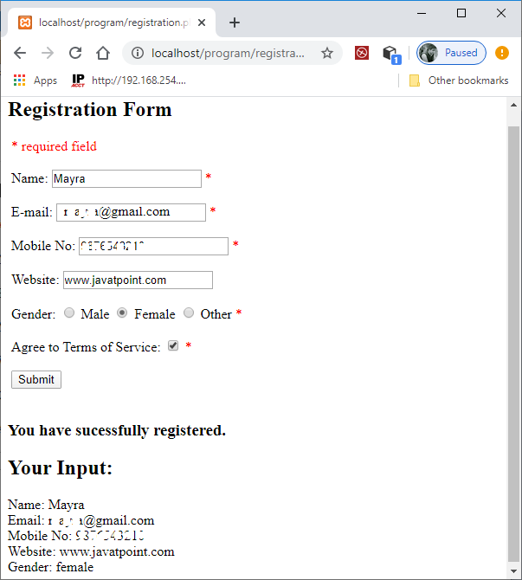

<!Doctype html>

<html lang="en">

<head>

<title> PHP Registration Form Example </title>

</head>

<body>

<?php

$nameErr = "";

$emailErr = "";

$genderErr = "";

$websiteErr = "";

$name = "";

$email = "";

$gender = "";

$comment = "";

$website = "";

if ($_SERVER["REQUEST_METHOD"] == "POST") {

if (empty($_POST["name"])) {

$nameErr = "Name Field is required";

} else {

$name = test_input($_POST["name"]);

if (!preg_match("/^[a-zA-Z-' ]*$/",$name)) {

$nameErr = "Only letters and white space allowed";

}

}

if (empty($_POST["email"])) {

$emailErr = "Email field is required";

} else {

$email = test_input($_POST["email"]);

if (!filter_var($email, FILTER_VALIDATE_EMAIL)) {

$emailErr = "Invalid email format";

}

}

if (empty($_POST["website"])) {

$website = "";

} else {

$website = test_input($_POST["website"]);

if (!preg_match("/\b(?:(?:https?|ftp):\/\/|www\.)[-a-z0-9+&@#\/%?=~_|!:,.;]*[-a-z0-9+&@#\/%=~_|]/i",$website)) {

$websiteErr = "Invalid URL";

}

}

if (empty($_POST["comment"])) {

$comment = "";

} else {

$comment = test_input($_POST["comment"]);

}

if (empty($_POST["gender"])) {

$genderErr = "Gender is required";

} else {

$gender = test_input($_POST["gender"]);

}

}

function test_input($data) {

$data = trim($data);

$data = stripslashes($data);

$data = htmlspecialchars($data);

return $data;

}

?>

<h1> PHP Registration Form Example </h1>

<form method="post" action="<?php echo htmlspecialchars($_SERVER["PHP_SELF"]);?>">

<b> Enter Name: </b> <input type="text" name="name" value="<?php echo $name;?>">

<span class="error"> * <?php echo $nameErr;?> </span>

<br> <br>

<b> Enter E-mail: </b> <input type="text" name="email" value="<?php echo $email;?>">

<span class="error"> * <?php echo $emailErr;?> </span>

<br> <br>

<b> Enter Number: </b> <input type="text" name="website" value="<?php echo $website;?>">

<span class="error"> * <?php echo $websiteErr;?> </span>

<br> <br>

<b> Message: </b> <textarea name="comment" rows="5" cols="40"> <?php echo $comment;?> </textarea>

<br> <br>

<b> Select Gender: </b>

<input type="radio" name="gender" <?php if (isset($gender) && $gender=="female") echo "checked";?> value="female"> Female

<input type="radio" name="gender" <?php if (isset($gender) && $gender=="male") echo "checked";?> value="male"> Male

<input type="radio" name="gender" <?php if (isset($gender) && $gender=="other") echo "checked";?> value="other"> Other

<span class="error"> * <?php echo $genderErr;?> </span>

<br> <br>

<input type="submit" name="submit" value="Register ">

</form>

<?php

echo "<h2> Your Input: </h2>";

echo $name;

echo "<br>";

echo $email;

echo "<br>";

echo $website;

echo "<br>";

echo $comment;

echo "<br>";

echo $gender;

?>

</body>

</html>

